Real Time Student Engagement

Monitoring Dashboard
Divyanshi Yadav Kartikey Shivhare Manas Singh Panwar Poornima Mandloi
Department of IT Department of IT Department of IT Department of IT
Acropolis Institute of Acropolis Institute of Acropolis Institute of Acropolis Institute of
Technology and Technology and Technology and Technology and
Research Research Research Research

Kirti Dang
CSE Department, ASET Amity University Noida, India dangkirti@gmail.com

Shanu Sharma
CSE Department, ASET Amity University Noida, India
Shanu.sharma16@gmail.com

This project introduces a Real-Time Student Engagement Monitoring Dashboard, a system designed to provide instant visibility into student activity during laboratory sessions. The dashboard classifies students into three engagement states—Active, Idle, and Off-task—and displays these states using color-coded indicators. The system aims to help faculty quickly identify students who may need assistance or intervention while reducing the burden of manual supervision. The proposed solution combines continuous activity tracking, automated status classification, and live visualization to create a scalable and practical monitoring tool for educational institutions. In addition to real-time monitoring, the system can support historical analysis and engagement analytics, enabling institutions to better understand participation pattern and improve the effectiveness of laboratory session.
Abstract -- Student engagement during laboratory sessions plays a crucial role in effective learning and academic performance. However, continuous monitoring of student activities by faculty members is challenging, especially in large computer labs, due to the limitations of manual supervision. Traditional monitoring methods are often inefficient, inaccurate, and unable to provide real-time insights into student participation and focus levels. This paper proposes a Real-Time Student Engagement Monitoring Dashboard, a system designed to track and analyze student activity during lab sessions. The proposed solution continuously collects activity-related data from student systems and classifies students into three engagement categories: Active, Idle, and Off-task. A live dashboard presents the engagement status of each student using intuitive color indicators—green for active, yellow for idle, and red for off-task—allowing faculty members to quickly identify students who may require attention. The system incorporates features such as real-time activity tracking, automatic dashboard updates, student-wise activity summaries, prolonged inactivity alerts, and class-level engagement analytics. Historical engagement trends and role-based access control further enhance the usability of the platform. To address the limitations of simple application-based monitoring, the proposed approach combines multiple activity indicators to improve the accuracy of engagement assessment. The implementation of this system aims to reduce faculty monitoring effort, improve laboratory discipline, enhance student productivity, and support data-driven academic decision-making. The proposed dashboard provides an efficient and scalable solution for real-time engagement monitoring in educational laboratory environments.
Keywords: Student Engagement Monitoring, Real-Time Dashboard, Activity Tracking, Educational Analytics, Lab Management System.

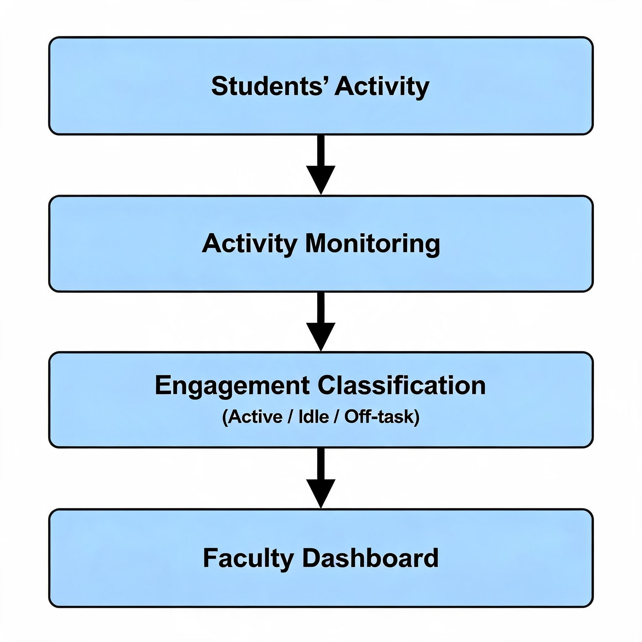

I. INTRODUCTION
Laboratory sessions are an essential component of technical and computer science education because they provide students with practical exposure to concepts learned in the classroom. During these sessions, students are expected to remain actively engaged in coding, debugging, experimentation, and problem-solving activities. However, in a typical computer lab environment, faculty members often supervise a large number of students simultaneously, making it difficult to continuously observe each student’s level of engagement. Manual monitoring has several limitations. Instructors may not immediately notice when a student becomes idle, distracted, or disengaged from the assigned task. This can lead to reduced productivity, delayed assistance for struggling students, and inconsistent discipline within the lab. Moreover, relying solely on visual observation is time-consuming and not scalable for large classes. Advances in real-time monitoring and educational analytics provide an opportunity to address these challenges through automated systems. By collecting activity-related data from student systems and analyzing behavioral patterns, it is possible to estimate engagement levels and present them in a visual format.

This figure illustrates the high-level workflow of the proposed Real-Time Student Engagement Monitoring System. Student activity data is collected from individual systems and transmitted through the API Layer for processing. The AI Module analyzes the collected data and classifies student engagement levels based on predefined criteria. The processed information is stored in the Database and displayed on the Faculty Dashboard for real-time monitoring. The system also generates alerts for prolonged idle or off-task behavior and provides analytics and reports for evaluating overall class engagement and productivity

STEP 2 – DATA PREPROCESSING AND NORMALIZATION
Clean and preprocess the collected activity data by removing redundant records and handling missing values. Normalize activity metrics into a standardized format to ensure consistent analysis across different student systems. Organize the processed data into structured records.

STEP 3 – ENGAGEMENT FEATURE EXTRACTION

Analyze the processed activity data to extract engagement-related features. These features may include typing frequency, mouse interaction rate, duration of active application usage, idle periods, and time spent on lab-related software.

STEP 4 – STUDENT ENGAGEMENT CLASSIFICATION

Apply predefined rules or machine learning models to classify student engagement levels. Based on the extracted features, categorize each student into one of the following states:

Active – Student is actively working on assigned tasks.

Idle – Student shows little or no interaction for a predefined duration.

Off-task – Student is engaged in activities unrelated to the lab work.

The classified status is updated continuously as new activity data becomes available.

STEP 5 – REAL-TIME DASHBOARD UPDATE

Transmit the classified engagement status to the faculty dashboard. Display each student's status using intuitive color indicators:

Green → Active

Yellow → Idle

Red → Off-task

The dashboard automatically refreshes at regular intervals to provide real-time visibility of classroom engagement.

STEP 6 – ALERT GENERATION AND ANALYTICS

Monitor the duration of Idle and Off-task states. If a student remains inactive or distracted beyond a predefined threshold, generate alerts for faculty intervention. Simultaneously, compute class-level analytics such as active student percentage, average engagement score, and engagement distribution across the laboratory.

STEP 7 – HISTORICAL DATA STORAGE AND REPORTING

Store engagement records and activity summaries in the database for future analysis. Generate historical reports and engagement trends that help faculty and institutions evaluate student participation patterns, identify recurring issues, and improve laboratory management strategies.

STEP 8 – CONTINUOUS MONITORING LOOP

Repeat the data collection, processing, classification, and dashboard update cycle throughout the laboratory session. The monitoring process continues until the session ends, ensuring continuous and up-to-date engagement tracking for all students.

The rapid adoption of digital technologies in education has transformed traditional laboratory environments into technology-enabled learning spaces. In computer laboratories, students perform programming, software development, data analysis, and other practical activities using computers. While these environments provide valuable hands-on learning experiences, they also present challenges for instructors who must monitor the engagement and participation of a large number of students simultaneously. Student engagement is considered a key factor influencing learning outcomes, academic performance, and skill development. Engaged students are more likely to participate actively in laboratory tasks, complete assignments effectively, and achieve better learning results. However, students may become distracted, remain idle, or engage in activities unrelated to the assigned work during lab sessions. Identifying such behavior through manual observation is difficult, particularly in large classrooms where a single instructor supervises many students.
Traditionally, faculty members rely on physical observation and periodic checks to assess student engagement. These methods are often time-consuming, subjective, and incapable of providing continuous monitoring. As a result, disengaged students may remain unnoticed for extended periods, reducing overall classroom productivity and learning effectiveness. Recent advancements in educational analytics, artificial intelligence, and real-time monitoring systems have created opportunities to automate the assessment of student engagement. By collecting activity data from student systems and analyzing interaction patterns, it is possible to estimate engagement levels and provide actionable insights to instructors. Such systems can support timely intervention, improve classroom management, and enhance the overall learning experience.
The proposed Real-Time Student Engagement Monitoring Dashboard is developed in response to these challenges. The system aims to provide continuous visibility into student activities, classify engagement levels in real time, and present the information through an intuitive dashboard. By combining activity tracking, intelligent analysis, and visual reporting, the system offers a scalable and efficient solution for monitoring student engagement in modern laboratory environments.

III. PROPOSED ALGORITHM
The proposed algorithm is designed to monitor student activities in real time, classify engagement levels, and display the results on a faculty dashboard. Algorithm: Real-Time Student Engagement Classification
Input: Activity data collected from student systems (keyboard activity, mouse activity, active application, idle time, browser usage, coding activity, etc.). Output: Student engagement status (Active, Idle, Off-task).

STEP 1 – STUDENT ACTIVITY DATA COLLECTION

Collect real-time activity data from student systems during laboratory sessions. The system continuously monitors parameters such as keyboard activity, mouse movements, active applications, browser usage, and system idle time. The collected data is timestamped and transmitted to the central monitoring server for further processing.

Clean and preprocess the collected activity data by removing redundant records and handling missing values. Normalize activity metrics into a standardized format to ensure consistent analysis across different student systems. Organize the processed data into structured records containing student identifiers, activity logs, timestamps, and application usage details.

II. BACKGROUND
The proposed Real-Time Student Engagement Monitoring Dashboard follows a systematic methodology to collect, process, analyze, and visualize student activity data during laboratory sessions. The methodology consists of multiple stages that work together to provide real-time insights into student engagement.

STEP 1 – Activity Data Collection

The system continuously collects activity-related information from student computers during laboratory sessions. Data sources include keyboard interactions, mouse movements, active applications, browser activity, and idle time. This information is gathered at regular intervals and transmitted securely to the central monitoring server.

STEP 2 – Data Preprocessing

The collected activity logs may contain redundant or incomplete records. Therefore, preprocessing is performed to clean the data, remove inconsistencies, standardize formats, and organize records based on student identifiers and timestamps. This ensures accurate and reliable analysis.

STEP 3 – Feature Extraction

Relevant engagement indicators are extracted from the processed data. These indicators include:

Typing frequency

Mouse activity rate

Active application duration

Idle time duration

Usage of lab-related software

Non-academic application usage

These features help in determining the actual level of student participation during laboratory activities.

STEP 4 – Engagement Analysis and Classification

The extracted features are analyzed using predefined rules or classification logic. Based on activity patterns, students are categorized into one of the following engagement states:

Active: Student is interacting with lab-related applications and performing assigned tasks.

Idle: Student shows minimal or no activity for a predefined period.

Off-task: Student is engaged in activities unrelated to laboratory work.

The classification process is performed continuously to ensure real-time monitoring.

STEP 5 – Dashboard Visualization

The classified engagement data is displayed on a live faculty dashboard. Each student's status is represented using color-coded indicators:

Green: Active

Yellow: Idle

Red: Off-task

The dashboard automatically refreshes and provides faculty members with an instant overview of the entire laboratory.

STEP 6 – Alert Generation

The system monitors the duration of idle and off-task behavior. If a student remains inactive or distracted beyond a predefined

IV. METHODOLOGY
The proposed Real-Time Student Engagement Monitoring Dashboard has various applications in educational institutions, particularly in computer laboratories and technology-enabled learning environments. The system helps faculty members, students, and institutions improve the overall effectiveness of laboratory sessions through continuous monitoring and engagement analysis.

- Application for faculty

Real-Time Student Monitoring - Faculty members can instantly view the engagement status of all students during laboratory sessions without physically checking each workstation.

Early Identification of Disengaged Students - The system helps identify students who are idle or off-task, enabling instructors to provide timely guidance and intervention.

Efficient Classroom Management - By reducing manual supervision efforts, faculty can focus more on teaching and assisting students with academic tasks.
Student engagement data can be used as an additional indicator for evaluating participation and practical involvement.

V. APPLICATION
This methodology enables efficient, scalable, and real-time monitoring of student engagement, reducing the dependency on manual supervision and improving laboratory productivity.
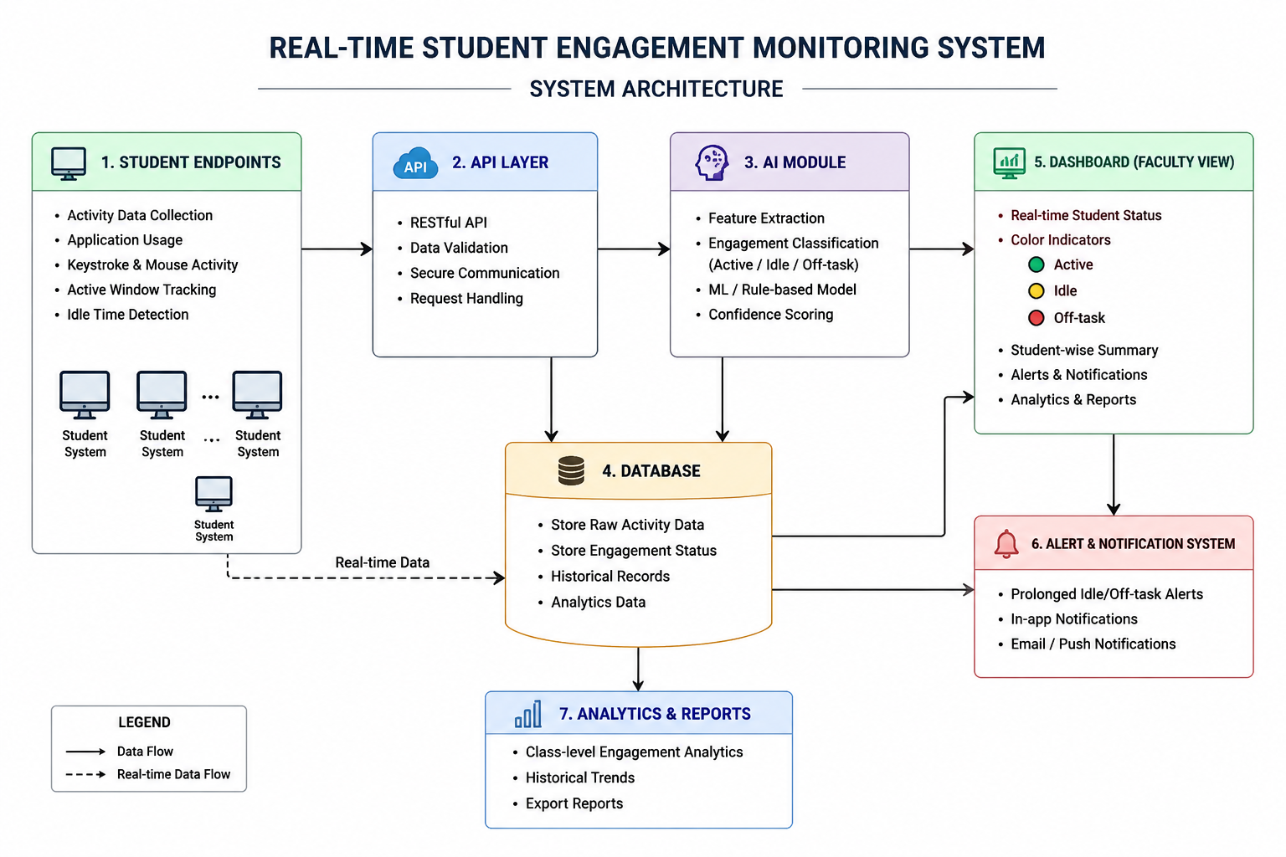
threshold, an alert is generated. These alerts enable faculty members to take immediate corrective actions and provide assistance when required.

STEP 7 – Data Storage and Analytics

All engagement records are stored in a centralized database. The stored information is used to generate:

Student-wise activity summaries

Class-level engagement statistics

Historical engagement trends

Performance reports

These analytics assist faculty and institutions in evaluating student participation and improving laboratory management.

2) Application for Educational Institution

Improved Laboratory Productivity - Continuous monitoring encourages students to remain focused on assigned activities, resulting in better utilization of laboratory resources.

Data-Driven Decision Making - Institution administrators can analyze engagement trends and use the insights to improve teaching strategies and laboratory management policies.

Large-Scale Monitoring - The system provides an efficient solution for monitoring large computer laboratories where manual supervision is difficult.

Academic Quality Enhancement - Regular engagement analysis helps institutions identify learning challenges and improve overall educational outcomes.

3) Application for Students

Increased Self-Awareness - Students can become aware of their engagement levels and adjust their behavior accordingly.

Improved Focus and Discipline - Knowing that activity is being monitored encourages students to remain attentive and complete assigned tasks efficiently.

Better Learning Outcomes - Active participation during laboratory sessions contributes to improved understanding of practical concepts and enhanced skill development.

4) Future Application

AI-Based Performance Prediction - Machine learning models can be integrated to predict student performance based on engagement patterns.

Smart Classroom Integration - The system can become a component of smart classroom ecosystems for comprehensive academic monitoring.

Personalized Learning Support - Engagement data can be used to provide personalized recommendations and learning assistance to students.

Remote and Hybrid Learning Monitoring - The dashboard can be extended to monitor engagement in online and hybrid learning environments.

VI. REFERENCE

1) Siemens, G., & Long, P., “Penetrating the Fog: Analytics in Learning and Education,” EDUCAUSE Review, Vol. 46, No. 5, pp. 30–40, 2011.
2) Ferguson, R., “Learning Analytics: Drivers, Developments and Challenges,” International Journal of Technology Enhanced Learning, Vol. 4, No. 5–6, pp. 304–317, 2012.
3) Baker, R. S., & Inventado, P. S., “Educational Data Mining and Learning Analytics,” in Learning Analytics, Springer, New York, 2014, pp. 61–75.
4) Romero, C., & Ventura, S., “Educational Data Mining: A Review of the State of the Art,” IEEE Transactions on Systems, Man, and Cybernetics, Vol. 40, No. 6, pp. 601–618, 2010.
5) Krumm, A., Means, B., & Bienkowski, M., Learning Analytics Goes to School: A Collaborative Approach to Improving Education, Routledge, New York, 2018.

